

CYCLE SHEET– III (PL/SQL Exercises)

NAME : DHAYA LAKSHMI A
REG.NO : 24MIS0158
SUBJECT CODE : ISWE103P
SUBJECT LAB : DATABASE SYSTEM LAB
LAB SLOT : L33 +L34
GUIDED BY : PROF. BHUVANA S

1. Write a PL/SQL block to display the reverse of numbers between 1 and 100.

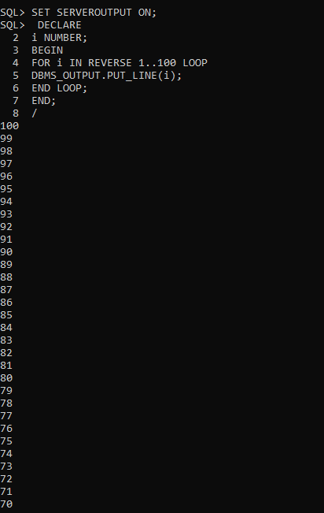

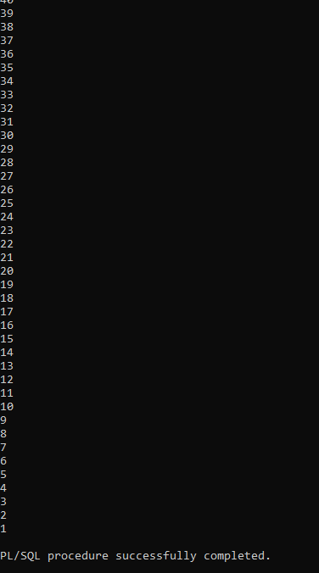
2. Project (Proj_num, Name, Location, Controlling Department, Budget)

Write a PL/SQL program to display the project name which has the highest budget than others.

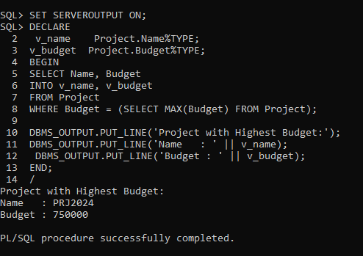
3. Employee (SSN, Name (fname, Minit, Lname), Sex, Address, salary,
DOB, Department, designation, SupervisorSSN) .

Write a PL/SQL program to get the employee number and check that the employee has got salary more than 50000. Otherwise, print the suitable message to denote that the employee is getting salary less than 50000.

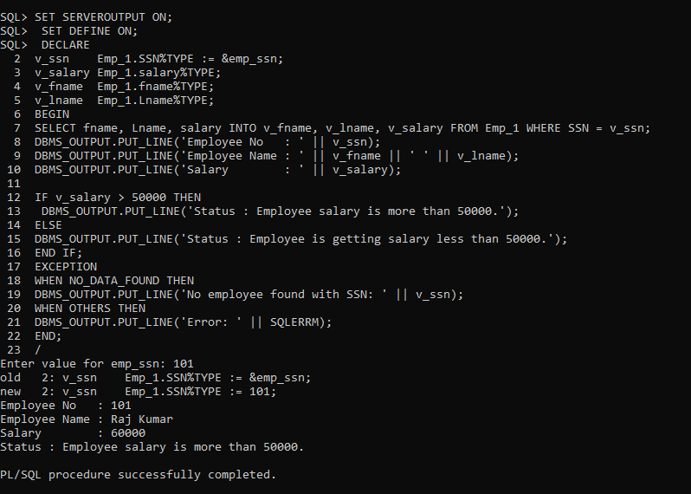
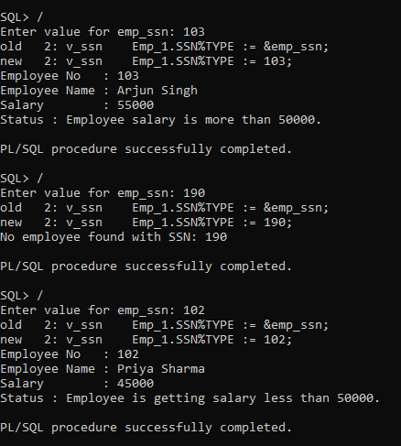

4. Write a procedure to display no of employee working in a department “SALES”;

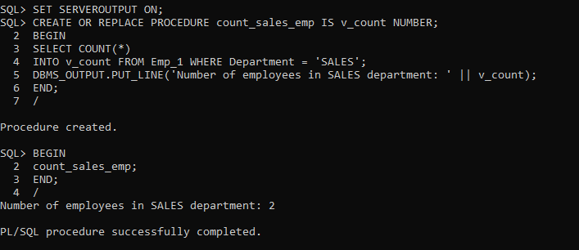

5. Write a program in PL/SQL to retrieve the records from the employees table and display them using cursors.

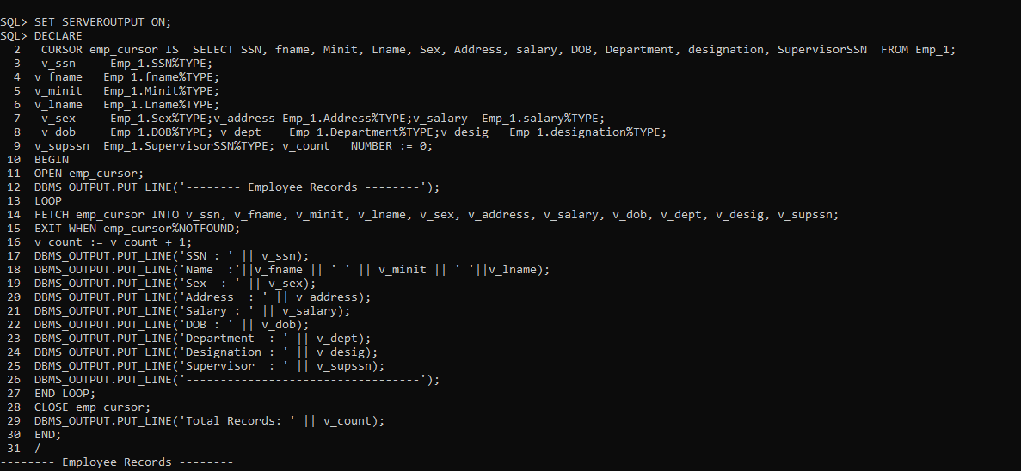
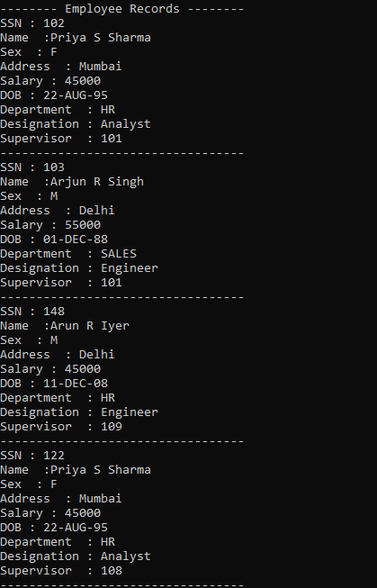
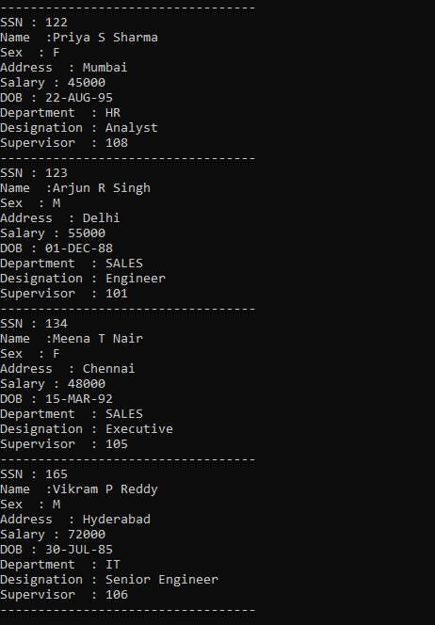
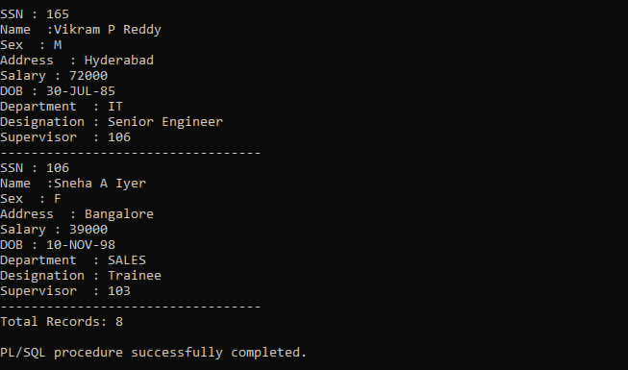
6. Create a trigger named update_restrict which display the warning message as “Deletion Not Permitted” if any one tries to delete a record from an employee table.

